
Population status of elephant in Tanzania 2014

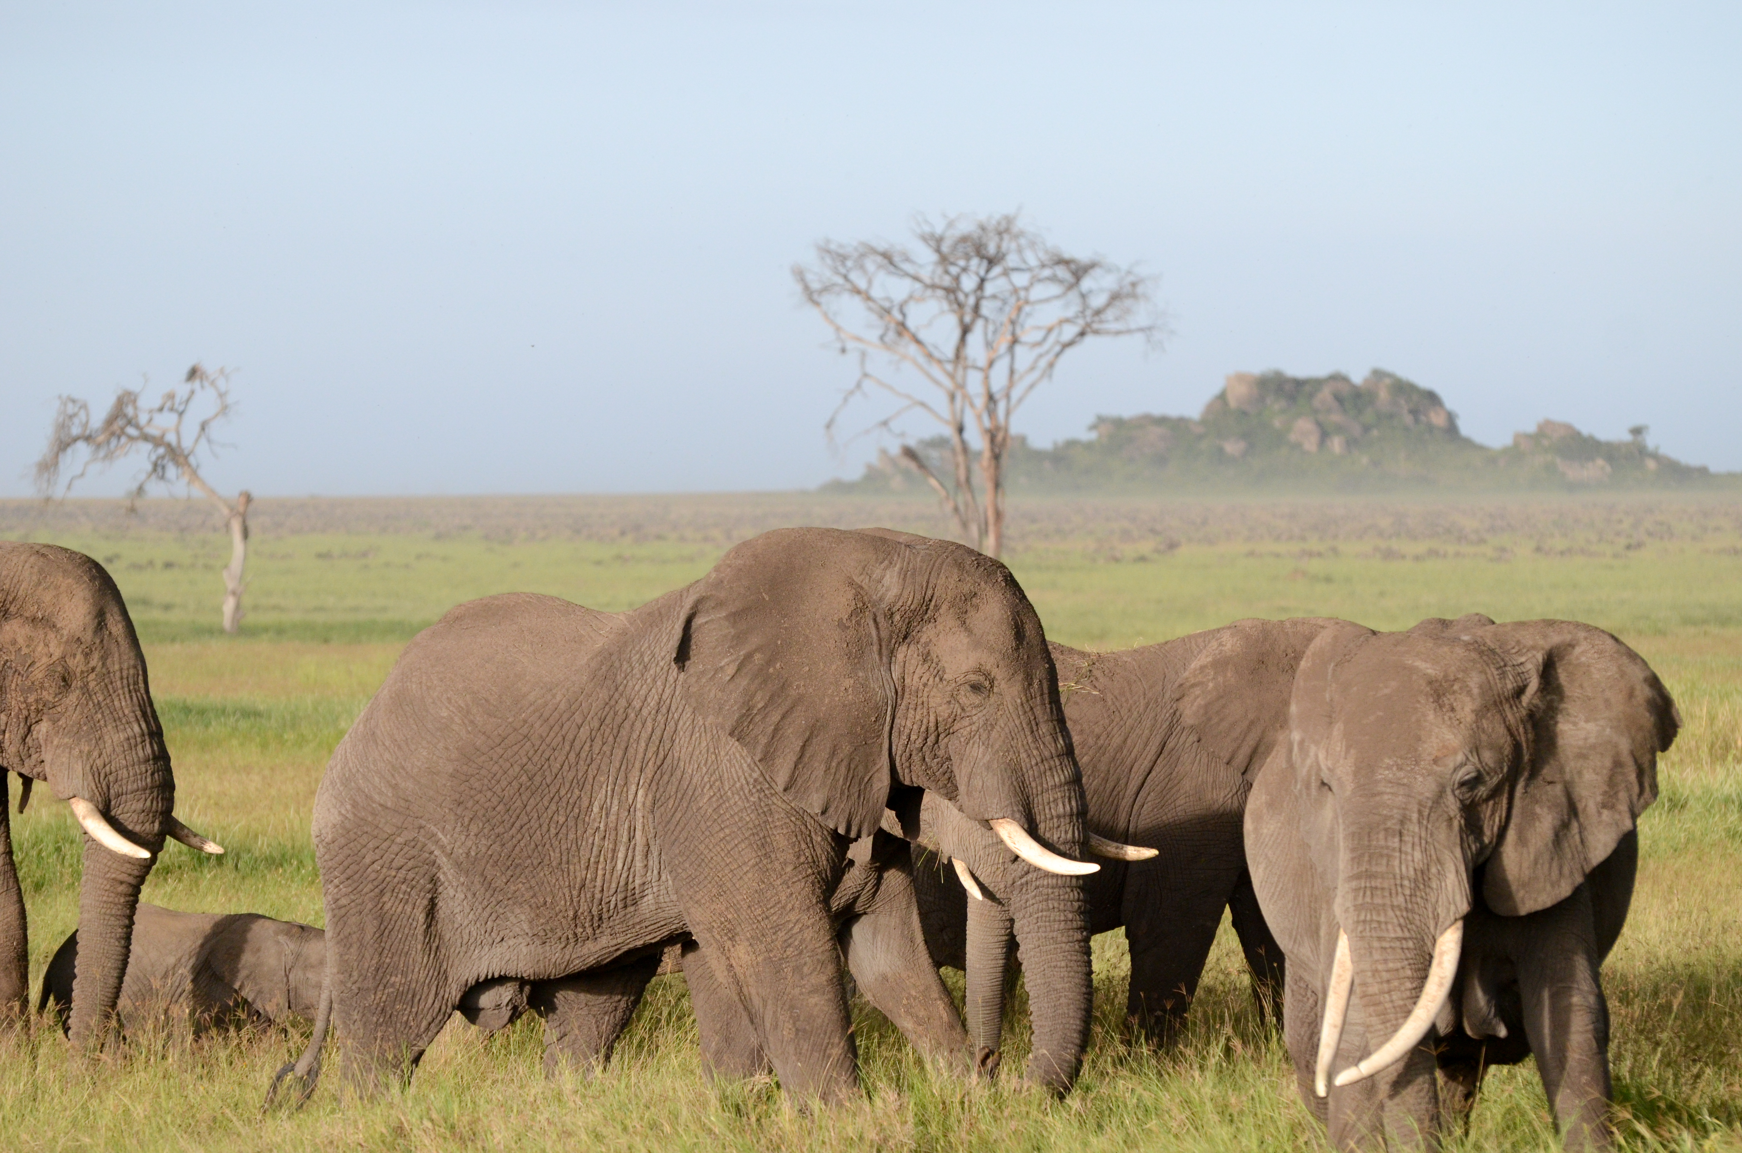

Tanzania Aerial Elephant Census

TAWIRI Wildlife Status Report
Population status of African elephant in Tanzania
Dry & Wet Season 2014

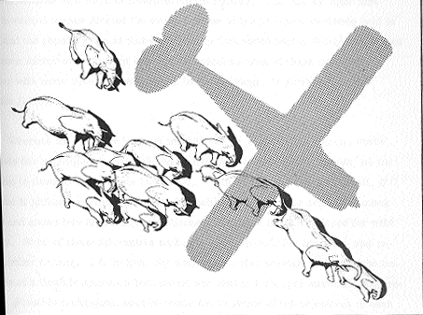
Conducted by
TANZANIA WILDLIFE RESEARCH INSTITUTE
Conservation Information and Monitoring Unit
To obtain a copy of this report please contact:
Tanzania Wildlife Research Institute
Conservation Information and Monitoring Unit
P.O. Box 661
Arusha, Tanzania
Tel: + 255 27 2544448
Email: cimu@tawiri.or.tz
info@tawiri.or.tz
Copyright © TAWIRI 2015
Citation: Tanzania Wildlife Research Institute, 2015 Population Status of Elephant in Tanzania 2014. TAWIRI Aerial Survey Report
Cover photo: © Anna Estes

Cooperation and Collaboration
The successful implementation of the Tanzania-wide Aerial Survey was a product of thorough planning, hard work, and good collaboration between government and non-governmental partners. The following partner institutions collaborated with TAWIRI for the successful implementation on the ground:

 | WILDLIFE DIVISION  P.O. Box 15472  Dar es Salaam, Tanzania  Contact: dw@mnrt.go.tz | Wildlife Division works to conserve, manage and develop wildlife and wetlands resources, and fosters sustainable utilization that will contribute towards poverty reduction.
 | TANZANIA NATIONAL PARKS  P.O. Box 3134  Arusha, Tanzania  Contact: dg@tanzaniaparks.com | Tanzania National Parks (TANAPA) was created in 1959 to manage and regulate the use of areas designated as National Parks.
 | NGORONGORO CONSERVATION AREA AUTHORITY  P.O. Box 1  Ngorongoro Crater, Tanzania  Contact: ncaa_faru@cybernet.co.tz | Ngorongoro Conservation Area Authority (NCAA) cooperates with NCA indigenous residents to conserve the natural and historical resources of this World Heritage Site while providing optimal social services to residents, staff and visitors.
 | FRANKFURT ZOOLOGICAL SOCIETY  P.O. Box 14935  Arusha, Tanzania  Contact: info@fzs.org | Frankfurt Zoological Society (FZS) is an internationally- operating NGO working to conserve wildlife and ecosystems and has been present in Tanzania since 1959.

Executive Summary
A countrywide aerial census was conducted from 17th May to 28th November 2014 to update the status of elephant population in Tanzania as part of the African continent-wide Great Elephant Census (GEC) census. Seven ecosystems were surveyed. Two census techniques were used: Total Count (TC) in the Tarangire-Manyara and Serengeti ecosystems and Systematic Reconnaissance Flight (SRF) in Selous-Mikumi, Ruaha-Rungwa, Katavi-Rukwa, Malagarasi-Muyovozi, and Burigi-Biharamulo Ecosystems. The country results in this report are extract from individual report of the respective ecosystems; for detailed information refer to the ecosystems reports.
- Estimates from other areas, which are known to harbor elephants, were obtained through non-GEC census funding, recent censuses, and other techniques. SRF was conducted in Mkomazi and Saadani National Parks in 2014 through government funding. Recent census results used include those from a total count of large animals in West Kilimanjaro and Lake Natron conducted in 2013. Dung count technique was used for Rubondo Island National Park and educated guesses for Arusha, Kilimanjaro national parks and Swagaswaga and Ibanda-Rumanyika game reserves.
- The results from various ecosystems using TC census methodology were: Tarangire-Manyara 4,202; Serengeti 6,087 and West Kilimanjaro-Lake Natron 200 elephants;
- The elephant population estimates using SRF technique were: Selous-Mikumi 15,217 (±1800 SE), Ruaha-Rungwa 8,272 (±1623 SE), Katavi-Rukwa 5,738 (±1375 SE), Malagarasi-Muyovozi 2,953 (±1308 SE) and Burigi-Biharamulo 110 (from one observation) (Table 1);
- The estimates for other areas were: Arusha National Park 200, Kilimanjaro National Park 100, Swaga Swaga Game Reserve 60 and Ibanda-Rumanyika 0. Also dung count estimate was used in Rubondo Island National Park, 102 (±18) elephants were estimated;
- Count and estimates from six key ecosystems give a total population size of 42,469 (±3,078 SE) elephants. Adding up all other protected areas, the elephant population size estimate in Tanzania is 43,521 (±3,078 SE), (Table 2);
- A total of 15,419 (±794 SE) carcasses were estimated in all key ecosystems including Mkomazi National Park and West Kilimanjaro-Natron Ecosystem (Table 3). Most of the carcasses were over one year old basing on the CITES classification;
- The current estimated elephant population in Tanzania has declined significantly from 109,051(±5,899 SE) in 2009 to 43,521 (±3,078 SE) in 2014; a 60% decline. The major declines occurred in Malagarasi-Muyovozi 81%, Ruaha-Rungwa 76%, and Selous-Mikumi 66%. Despite this, elephants increased by 98% in Serengeti and 64% in Tarangire-Manyara in reference to 2009 countrywide elephant census (Table 2);
From the census results, it is evident that elephant population in Tanzania has declined. Therefore, we recommend the following to enhance conservation efforts;
- To conduct an intensive study to more precisely determine the causal factors influencing the large variation in elephant numbers observed in 2014, in comparison to previous censuses;

- Movement patterns in the ecosystem are still poorly understood, therefore there is a need to fit satellite collars to selected individuals that would allow us to understand movements and better conserve the population;

- Conduct a study on to understand dynamic of poachers’ tactics;

- To repeat census in the ecosystems that have registered sharp decline in elephant population (e.g., Ruaha-Rungwa) preferably during the next dry season so as to confirm current and previous results;

- To conduct a study that addresses the influence of land use changes, especially human settlements, livestock keeping, lumbering and agriculture on elephant numbers and distribution, so as advice on the most appropriate conservation approaches;

- To continue supporting research on elephant ecology with emphasis on their movement, demography, causes of death and quality of their habitat;

- To carry out a study that will establish alternative livelihood strategies that will minimize over reliance by surrounding communities on natural resources available in the wildlife areas;

Table of Contents
Cooperation and Collaboration ii
Executive Summary iii
List of figures and tables vi
List of Abbreviation and Acronyms vii
1. Introduction 1
2. Methods 1
2.1 Total Count 1
2.2 Systematic Reconnaissance Flight (SRF) 2
2.3 Carcass Estimates 3
2.4 Collating census estimates from other areas 3
3. Results 4
3.1 Total Count 4
3.1.1 Serengeti Ecosystem 4
3.1.2 Tarangire–Manyara Ecosystem 5
3.2 Systematic Reconnaissance Flight (SRF) 6
3.2.1 Katavi-Rukwa Ecosystem 6
3.2.2 Malagarasi-Muyovozi Ecosystem 7
3.2.3 Selous-Mikumi Ecosystem 8
3.2.4 Ruaha-Rungwa Ecosystem 8
3.3 Best Estimates of Elephant Population Size in Other Areas 10
4. Discussion and Conclusion 11
Results summary 1
5. References 7
6. Acknowledgements 8

List of figures and tables
Figure 1: Surveyed ecosystems in 2014 Tanzania 2
Figure 2: Trend of elephant population size in the Serengeti ecosystem (1986-2014) 4
Figure 3: Population trend of the African elephant in Tarangire-Manyara Ecosystem from 1995 to 2014 5
Figure 4: Trend in elephant population in the Katavi-Rukwa Ecosystem (1991-2014) 6
Figure 5: Trend in elephant population in the Malagarasi-Muyovosi Ecosystem (1991-2014) 7
Figure 6: Trend in elephant population in the Selous-Mikumi Ecosystem (1976-2014) 8
Figure 7: Trend in elephant population in the Ruaha-Rungwa Ecosystem (1993-2014) 9
Figure 8: Distribution of elephant population density (i) and carcass density (ii) in all major ecosystems in Tanzania 6
Table 1: Population estimate of elephants in various ecosystems for 2014 censuses (1-7) 1
Table 2: Ecosystem summary - population estimates of elephants in Tanzania 2009 and 2014 4

List of Abbreviation and Acronyms
CIMU Conservation Information and Monitoring Unit
FSO Front Seat Observer
FZS Frankfurt Zoological Society
GEC Great Elephant Census
GCA Game Controlled Area
GPS Global Positioning System
GR Game Reserve
IUCN International Union for Conservation of Nature
MIKE Monitoring the Illegal Killing of Elephants
NCA Ngorongoro Conservation Area
NCAA Ngorongoro Conservation Area Authority
NP National Park
PA Protected Area
RSO Rear Seat Observer
SE Standard Error
SRF Systematic Reconnaissance Flight
TANAPA Tanzania National Parks
TAWIRI Tanzania Wildlife Research Institute
TC Total Count
TWCM Tanzania Wildlife Conservation Monitoring
URT United Republic of Tanzania
WD Wildlife Division
WMA Wildlife Management Area

1. Introduction
This report updates the status of African elephant (Loxodonta africana) population in Tanzania. The last country elephant status report was produced in 2009, which reported an estimate of 109,168 elephants in Tanzania (TAWIRI, 2009). Since then the population has experienced high mortality in various ecosystems notably Selous-Mikumi and Ruaha-Rungwa Ecosystems (TAWIRI, 2013), which prompted a need to understand the status of the African elephant in Tanzania.
Countrywide censuses were conducted in the main ecosystems for seven months consecutively starting from May to November 2014. Surveyed ecosystems included: (i) Serengeti, (ii) Tarangire-Manyara, (iii) Katavi-Rukwa, (iv)Malagarasi-Muyovozi, (v) Selous-Mikumi, (vi) Ruaha-Rungwa and (vii) Burigi-Biharamulo ecosystems (Figure 1). The main objective of the survey was to update the current elephant population size and thereafter determine population trends at ecosystems and national levels. However, the 2014 survey did not cover all areas that are inhabited by elephants in Tanzania, but concentrated efforts on the strongholds of the species. Records of previous censuses or experts’ knowledge (ecologists and project managers) in areas that were not surveyed were used to determine the “best estimate” of the elephant population in Tanzania.

2. Methods

2.1 Total Count
Aerial Total Count (TC) surveys were conducted in the Serengeti Ecosystem from 19th May to 6th June 2014 and Tarangire-Manyara Ecosystem from 17th August to 2nd September 2014. These censuses were carried out using light aircraft, each with a crew of four, including a pilot, front seat observer (FSO) and two rear seat observers (RSO).
The census zones were divided into counting blocks that are historically used for total count surveys. Each block was searched by flying flight paths spaced 0.6, 1.0, 1.2 or 2 km apart for Serengeti and 0.5, 1.0 or 2km for Tarangire-Manyara depending on habitat type and terrain. All elephants were located and accurately counted. Elephant herd size and their geographical location (GPS coordinates) was recorded. Photographs were taken using a 50 mm lens digital camera where large herds with more than 10 individuals were observed. Photographs were also taken for all carcasses sighted.
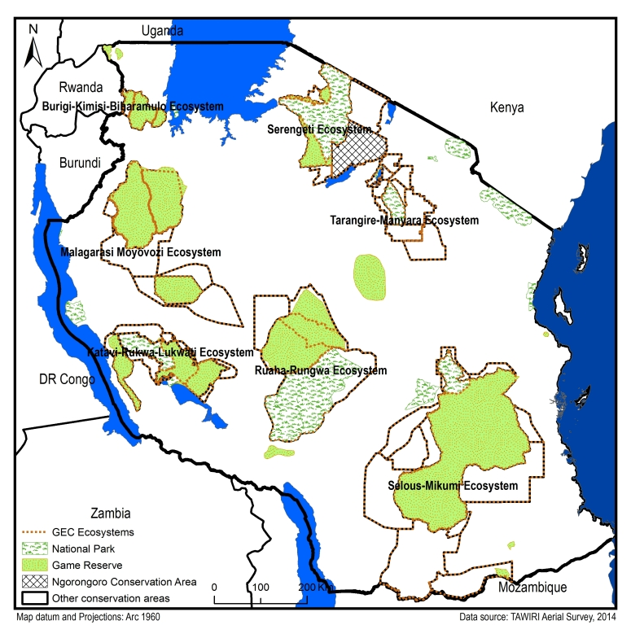
Figure 1: Surveyed ecosystems in 2014 Tanzania

2.2 Systematic Reconnaissance Flight (SRF)
The censuses were conducted following Systematic Reconnaissance Flight (SRF) technique as described by Norton-Griffiths (Norton-Griffiths, 1978). Cessna 182 aircrafts were used in each ecosystem: each flying at a target height of 350 ft. (100 m) above ground and a target speed of 180 km/h.
Planned transects were spaced 5km apart with variable orientations (North-South; East-West; Southwest-Northeast and Northwest-Southeast) depending on nature of terrain, ecological gradient and aiming at maximizing the number of samples. Transects were a priori evenly subdivided into subunits between 2.1 and 2.5 km in length (typically around 40 seconds of flying time) and uploaded onto GPS units. Geo-referencing of aircraft on transect was determined by GPS, according to prior-prepared UTM coordinates.
Census data were entered into computer and analysed using software developed specifically for SRF surveys and Excel sheets. Population estimates were calculated using Jolly's Method 2 of Unequal Sized Units (Jolly, 1969). Animal numbers were added to a database together with their associated geographical locations. ArcGIS 10.1 and QGIS 2.6 were used for creating species distribution and density maps.

2.3 Carcass Estimates
In both TC and SRF census techniques, observers were instructed to count elephant carcasses like any other species of large animals. Carcasses were divided into four categories based on the body structure, colour of the bone and other factors (see below), which is a reflection of the approximate age since the animal died (Craig, 2012).
Carcass 1: Fresh (<1 month). Still has flesh giving the body a rounded appearance. Vultures probably present and ground still moist from body fluids.
Carcass 2: Recent (<1 year). Rot patch and skin still present. Skeleton not scattered
Carcass 3: Old (>1 year). Clean bones, skin usually absent, vegetation re-grown in rot patch
Carcass 4: Very old (up to 10 years). Bones scattered and turning grey.
Carcass ratio: The carcass ratio was calculated by adding all counted carcasses divide by total number of live elephant and all counted carcasses.

2.4 Collating census estimates from other areas
Not all areas that are inhabited by elephants in Tanzania were surveyed in the 2014 censuses. For some areas, which could not be surveyed, population estimates were sought from various sources and collated into the elephant database. Some of the estimates are based on (i) dung count, (ii) managers or ecologists’ estimates and (iii) estimates of censuses conducted within the last 2 years, with the assumption that there has not been a major change in population size. However, we could not get estimates for some elephant populations which, although they are known to exist they have never been counted or even speculated.

3. Results

3.1 Total Count

3.1.1 Serengeti Ecosystem
The census covered 23,663 km², including Serengeti National Park, Ngorongoro Conservation Area, Maswa Game Reserve, Ikorongo & Grumeti Game Reservesand Loliondo Game Controlled Area. Other areas included IKONA Open and Wildlife Management Area (WMA) and Makao Open and WMA. A total of 6,087 elephants were counted giving a crude density of 0.18 elephants/km² including the less favoured Serengeti Plains. This is an increase of 98% compared to the 2009 count of 3,068 (Figure 2). The increase is attributed to (i) natural growth (ii) immigration from Maasai-Mara (iii) enhanced TC technique and (iv) effective protection

Figure 2: Trend of elephant population size in the Serengeti ecosystem (1986-2014)

3.1.2 Tarangire–Manyara Ecosystem
A total of 15,195 km² was surveyed including Lolkisale GCA, Mto wa Mbu GCA, Kwakuchinja OA, Kibaoni OA, Engaruka GCA, Mkungunero GR, Simanjiro GCA Tarangire National Park, Burunge and Makame WMA. The elephant population size was counted as 4,202 giving a density of 0.21 elephants per square kilometre. The present count indicates an increase of 1,637 elephants (64%) from 2561 counted in 2009; this is the highest population size ever recorded since 1995 (Figure 3). Most of the elephants (78%) were found within Tarangire National Park. As expected during the dry season, elephants concentrated along main water sources including the Tarangire River.

Figure 3: Elephant Population trend in Tarangire-Manyara Ecosystem from 1995 to 2014
A total of 178 carcasses were counted in the entire Tarangire-Manyara ecosystem. Out of the total, only three (1.7%) carcasses were in category I & II (new and recent) and 22 (12.4%) carcasses were in category III (old). The remaining 153 (86%) carcasses were in category IV (very old).

3.2 Systematic Reconnaissance Flight (SRF)

3.2.1 Katavi-Rukwa Ecosystem
A total area of 19,953 km² was covered in the Katavi-Rukwa Ecosystem including; Katavi National Park, Rukwa, Lukwati and Lwafi Game Reserves, Nkamba Forest Reserve, Uruwira Plateau, Usevia Open Area and Lukwati outside. A total of 529 elephants were counted, which gave an estimate of 5,783 (± 1,375 SE) elephants for the Katavi-Rukwa Ecosystem; that is, between 4,256 and 7,310 elephants in this ecosystem. The current estimate is similar to that of 2012 (7,107 ± 2,627 elephants) (Figure 4). Comparing estimates of 2009 and 2014 for Katavi NP and Rukwa GR separately, the elephant population remained stable for Katavi NP (d=0.07, P>0.05) and significantly declined for Rukwa Game Reserve (d=2.72, P>0.05).
A total of 65 elephant carcasses were recorded in the Katavi-Rukwa ecosystem, giving an estimate of 616 (± 104 SE) carcasses. Carcasses were observed across the entire ecosystem with pockets of high density in Rukwa Game Reserve, Katavi National Park and Lukwati Game Reserve. Less than one percent of the carcasses were fresh or less than one month old.

Figure 4: Elephant population trend in Katavi-Rukwa Ecosystem (1991-2014)

3.2.2 Malagarasi-Muyovozi Ecosystem
A total area of 44,809 km² was covered including Ugalla, Moyowosi and Kigosi GRs, open areas around Ugalla GR, Malagarasi core wetland including Luganzo GCA. The result of elephant population size for Malagarasi -Muyovozi Ecosystem needs to be treated with caution. The current estimate of elephant population size in the entire ecosystem is 2,953 (± 1,308) in 12 groups, which are too few group sightings to generate reliable estimates. More elephants were counted in Moyowosi (58%) followed by Ugalla GRs (22%). The results indicate a significant decline of elephant in the entire ecosystem. In 2009 estimated population was 14,907 (±2,962 SE) compared to the current population of 2,953 (Figure 5). The estimated elephant carcasses in four categories are 1,183 (± 152) carcasses for the ecosystem. The estimated numbers of carcasses does not fully explain the decline of the population size; a loss of about 11,954 elephants from 2009.

Figure 5: Elephant population trend in Malagarasi-Muyovosi Ecosystem (1991-2014)

3.2.3 Selous-Mikumi Ecosystem
A total area of 105,370 km² was surveyed including Mikumi National Park, Selous Game Reserve, WMAs, Selous-Niassa Corridor, Kilombero Game Controlled Area and open areas. A total of 903 elephants were counted giving an estimate of 15,217 ± 1,800 elephants for the entire ecosystem. Most (11,419 ±1,566 elephants 75%) were recorded in the Selous GR. The rest of the elephant population was found in Selous-Niassa corridor (7%; 1,161 ±684), Liwale area (7%; 1,095 ±417) and Mikumi National Park (5%; 885 ±300). There is a significant decline of elephant population from 44,806 (±2,874) estimated in 2009; a decline of over 66% for a period of five years. However, the current estimate (15,217 ± 1,800) is similar to that of 2013 (13,084 ± 1,816 SE), suggesting that the rapid rate of decline has been managed (Figure 6).

Figure 6: Elephant population trend in Selous-Mikumi Ecosystem (1976-2014)

3.2.4 Ruaha-Rungwa Ecosystem
The elephant population estimate in the Ruaha - Rungwa ecosystem is 8,272 ± (1,623 SE) from 483 counted elephants. The survey covered and area of 50,368 km². The 2014 result is indicating a continuing declining trend from 34,664 (±4,178) elephants in 2009 a decline of over 76% for a period of five years (Figure 7). The long-term data from 1993 to 2014 signalled a declining trend since 2009.

Figure 7: Elephant population trend in Ruaha-Rungwa Ecosystem (1993-2014)
However, the 2014 carcass estimate (3,296) is relatively small and does not fully account for the loss of elephant from 2013 to 2014 census. On the other hand, the long-term data shows a declining tend of the elephant population in the ecosystem. This suggests that there has been considerable mortality over the past year, which is a continuation of previous years. However, part of the change in numbers may have been due to emigration to Lukwati and Moyowosi/Ugalla, but this alone does not account for such a big change. Because there is uncertainty in both conclusions we recommend that further evidence is obtained on two major aspects. First, evidence is needed on what has caused the deaths of the observed carcasses. In particular, evidence is required on whether poachers have changed their methods and are now concealing the carcasses. This hypothesis would account for why relatively few carcasses have been seen, and this can be tested by ground observations. Secondly, evidence is required on long-distance movements of animals. Communities that live in between the protected areas and management staff from the areas should be interviewed to see if they have evidence of large herds moving through in the past year. Satellite collars should be placed on animals in Moyowosi and Lukwati to detect whether they move back to Ruaha-Rungwa again (animals already in Ruaha-Rungwa would be less instructive because they may not move which would prove nothing). This evidence would test the emigration hypothesis. We also strongly recommend repeating the census in the next dry season in order to confirm the results.

3.3 Best Estimates of Elephant Population Size in Other Areas
(i) Recent censuses: The data for areas that were not surveyed in 2014, previous census were used to provide “best estimates” of the population size.
- Mkomazi National Park – In 2014, a joint total count with Tsavo only 59 elephants were counted.
- West Kilimanjaro - Lake Natron: In 2013, total count was conducted in Amboseli - West Kilimanjaro. The counted elephants for West Kilimanjaro-Lake Natron were 200 (Kenana et al. 2013).

(ii) Dung count method: Dung count technique was used in Rubondo Island NP to provides population estimates. The estimated number of elephants was 102 (±18) (Mwambola 2014).
(iii) Educated guess: For areas where no recent censuses data were available experienced personnel in a specific park or game reserves were requested to provide estimates of their elephant population sizes. This type of estimate is also known as “educated guess”. Ecologists for national parks and project managers for game reserves provided the “best estimates”.
- Arusha National Park – based on ecologist experience on ground monitoring the estimated number of elephants in Arusha NP are around 200 (Gladness, pers.com);
- Kilimanjaro National Park – based on ecologist monitoring experience of elephant herds in Kilimanjaro NP, elephants are around 100 (Kikoti pers. com);
- Saadani National Park – Based on single observation (30+ individuals, one herd was counted during the SRF survey);
- Swagaswaga Game Reserve – Estimated number of elephants by Project Manager is 60 individuals (Mnkeni, pers.com).

4. Discussion and Conclusion
Compared to the 2009 countrywide census, the change in elephant population size occurred in almost all ecosystems following upward or downward trends. Two ecosystems; namely Serengeti and Tarangire-Manyara recorded upward trends of 98% and 64% respectively. Katavi-Rukwa Ecosystem maintained its elephant population trend even though majority of elephants were concentrated in Katavi National Park and Lukwati Game-Reserve. Ecosystems that experienced downward trends are Selous-Mikumi Ecosystem (66%), Ruaha-Rungwa Ecosystem (76%) and Malagarasi-Muyovozi Ecosystem (81%). These three ecosystems were the major contributors of elephant population size in Tanzania.
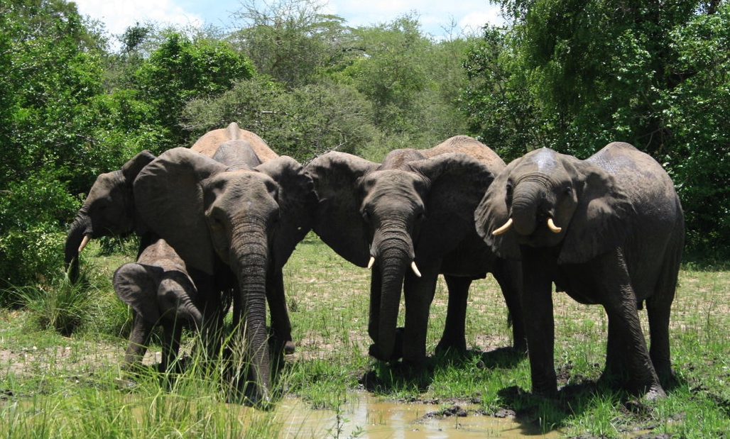Photo: The census objectives were to assess the population status of African elephant in the Selous-Mikumi Ecosystem. ©K. Skinner

Results summary
Results are summarized per individual ecosystem in Table 1 and all ecosystems are added up in Table 2. In Figure 8, population density of elephants and carcasses are presented for all ecosystems that were surveyed in 2014 censuses.
Table 1: Population estimate of elephants in various ecosystems for 2014 censuses (1-7)
1. Total Count – Serengeti Ecosystem
Census Zones | Area (km²) | Count
IKONA WMA & Open Area | 723 | 232
Makao WMA & Open Area | 1,145 | 81
Loliondo Game Controlled Area | 6,210 | 76
Grumeti Game Reserve | 389 | 0
Ikorongo Game Reserve | 574 | 160
Maswa Game Reserve | 2,875 | 179
Ngorongoro Conservation Area | 8,252 | 199
Serengeti National Park | 13,017 | 5160
Total | 23,663 | 6087

2. Total Count – Tarangire - Manyara Ecosystem
Census Zones | Area (km²) | Count
Engaruka OA | 1452 | 44
Burunge WMA (Kibaoni) | 849 | 220
Kwakuchinja OA | 547 | 70
Lolkisale GCA | 818 | 425
Manyara NP | 593 | 34
Mkungunero GR | 2523 | 2
Mto wa Mbu GCA | 1291 | 19
Simanjiro GCA | 3324 | 21
Tarangire NP | 2637 | 3,282
Makame WMA | 4691 | 85
Total | 15,195 | 4,202

3. Total Count - West Kilimanjaro - Lake Natron Ecosystem
Census Zones | Surveyed area (km²) | Counted Elephant
West Kilimanjaro | 3,013 | 137
Lake Natron | 7,047 | 63
Total | 10,060 | 200
4. SRF Estimate - Katavi-Rukwa Ecosystem
Census Zones | Surveyed area (km²) | Counted Elephant | Population estimate | Standard Error
Katavi National Park | 4,187 | 352 | 3,128 | 992
Lukwati Game Reserve | 3,539 | 73 | 1,090 | 281
Lwafi Game Reserve | 1,503 | 0 | 0 | 0
Msaginia Open Area | 2,254 | 0 | 0 | 0
Nkamba-Lwafi | 1,122 | 22 | 209 | 111
Out Lukwati E | 695 | 63 | 1,116 | 896
Out Lukwati S | 246 | 4 | 73 | 73
Out Rukwa E | 328 | 0 | 0 | 0
Out Rukwa S | 131 | 0 | 0 | 0
Rukwa Game Reserve | 4,092 | 15 | 122 | 67
Urawira Open Area | 456 | 0 | 0 | 0
Usevia Open Area | 1,399 | 0 | 0 | 0
Total | 19,953 | 529 | 5,738 | 1,375
5. SRF Estimate - Malagarasi-Muyovosi Ecosystem
Census Zones | Surveyed area (km²) | Counted Elephant | Population estimate | Standard Error
Ugalla East | 6,341 | 8
Ugalla G.R | 4,913 | 36
Ugalla West | 1,921 | 0
Ugalla North | 2,846 | 0
Moyowosi G.R | 11,320 | 91
Ramsar Core Area | 8,195 | 29
Kigosi G.R | 8,275 | 0
Makere | 790 | 0
Out Moyowosi | 208 | 0
Total | 44,809 | 164 | 2,953 | 1,308

6. SRF Estimate - Selous-Mikumi Ecosystem
Census Zones | Surveyed area (km²) | Counted elephant | Population estimate | Standard Error
Kilombero GCA | 3,744
Mikumi National Park | 3,385 | 66 | 885 | 300
Out E (Ngarambe-Tapika) | 1,849
Out Mikumi | 692 | 8
Out Mikumi W | 427
Out N (Kidunda-Gonabis) | 1,280
Out S (Muhuwesi GCA) | 5,726 | 1
Out S (Masasi) | 860
Out SE (Liwale) | 11,996 | 63
Out W (Mahenge) | 9,178 | 17
Out W (Mbalika) | 3,173 | 16
Selous Game Reserve | 47,323 | 661 | 11,419 | 1,566
Selous-Niassa corridor | 16,097 | 71
Total | 105,730 | 903 | 15,217 | 1,800

7. SRF Estimate - Ruaha-Rungwa Ecosystem
Census Zones | Surveyed area (km²) | Counted Elephant | Estimated Population | Standard Error
Itigi thickets | 5,607 | 8 | 228 | 226
Kizigo G.R | 5,057 | 50 | 758 | 506
Muhesi G.R | 4,252
Out -South-West | 58
Out South | 25
Out-East | 253
Out-East (Lunda Mkwambi) | 4,591 | 18 | 275 | 163
Out-South (Kapunga rice farm) | 86
Out-West | 632
Outside-North | 680
Ruaha N.P | 20,110 | 244 | 4,210 | 1,164
Rungwa G.R | 9,018 | 163 | 2,801 | 971
Total | 50,368 | 483 | 8,272 | 1,623

Table 2: Ecosystem summary - population estimates of elephants in Tanzania 2009 and 2014
 | 2009 |  |  | 2014
Ecosystem / PA | Estimate | SE | Area (km²) | Estimate | SE | Area (km²) | Method* | Status
Serengeti | 3,068 |  | 21,884 | 6,087 |  | 33,185 | TC | Increase
Tarangire-Manyara | 2,561 |  | 12,766 | 4,202 |  | 18,725 | TC | Increase
W. Kilimanjaro-L. Natron | - | - |  | 200 |  | 10,060 | TC | New record
Katavi-Rukwa | 6,396 | 920 | 10,274 | 5,738 | 1,375 | 19,953 | SRF | Stable
Malagarasi-Muyovosi | 15,198 | 2,751 | 45,532 | 2,953 | 1,308 | 44,809 | SRF | Decline
Selous-Mikumi | 44,806 | 2,874 | 107,968 | 15,217 | 1,800 | 105,730 | SRF | Decline
Ruaha-Rungwa | 34,664 | 4,178 | 43,641 | 8,272 | 1,623 | 50,368 | SRF | Decline
Burigi-Biharamulo | 1,295 | 785 | 7,292 | 110 |  | 4,713 | SRF | Decline
Saadani National Park | 255 | 178 | 2,502 | 30 |  | 1,154 | SRF | Inconclusive
Mkomazi National Park | 209 | 131 | 3,015 | 59 |  | 3,107 | TC
Ibanda-Rumanyika | 0 | - |  | 0 |  | - | PM
Rubondo Island NP | 49 | - |  | 102 |  | 237 | DC | Increase
Arusha National Park | 100 | - | 322 | 200 |  | 316 | ECL | Increase
Swagaswaga GR | - | - |  | 60 |  | 871 | ECL | Possible decline
Kilimanjaro National Park | 450 | - |  | 100 |  | 1,652 | ECL
Mahale Mt. National Park | - | -
Wami-Mbiki Wma |  | - |  |  |  | 2,344
Total | 109,051 | 5,899 |  | 43, 330 | 3,078
* Method: ECL-Ecologist; PM-Project Manager; DC-Dung Count; SRF-Systematic Reconnaissance Flight, TC-Total Count.
Table 3: Ecosystem summary – elephant carcasses estimates in 2014 survey
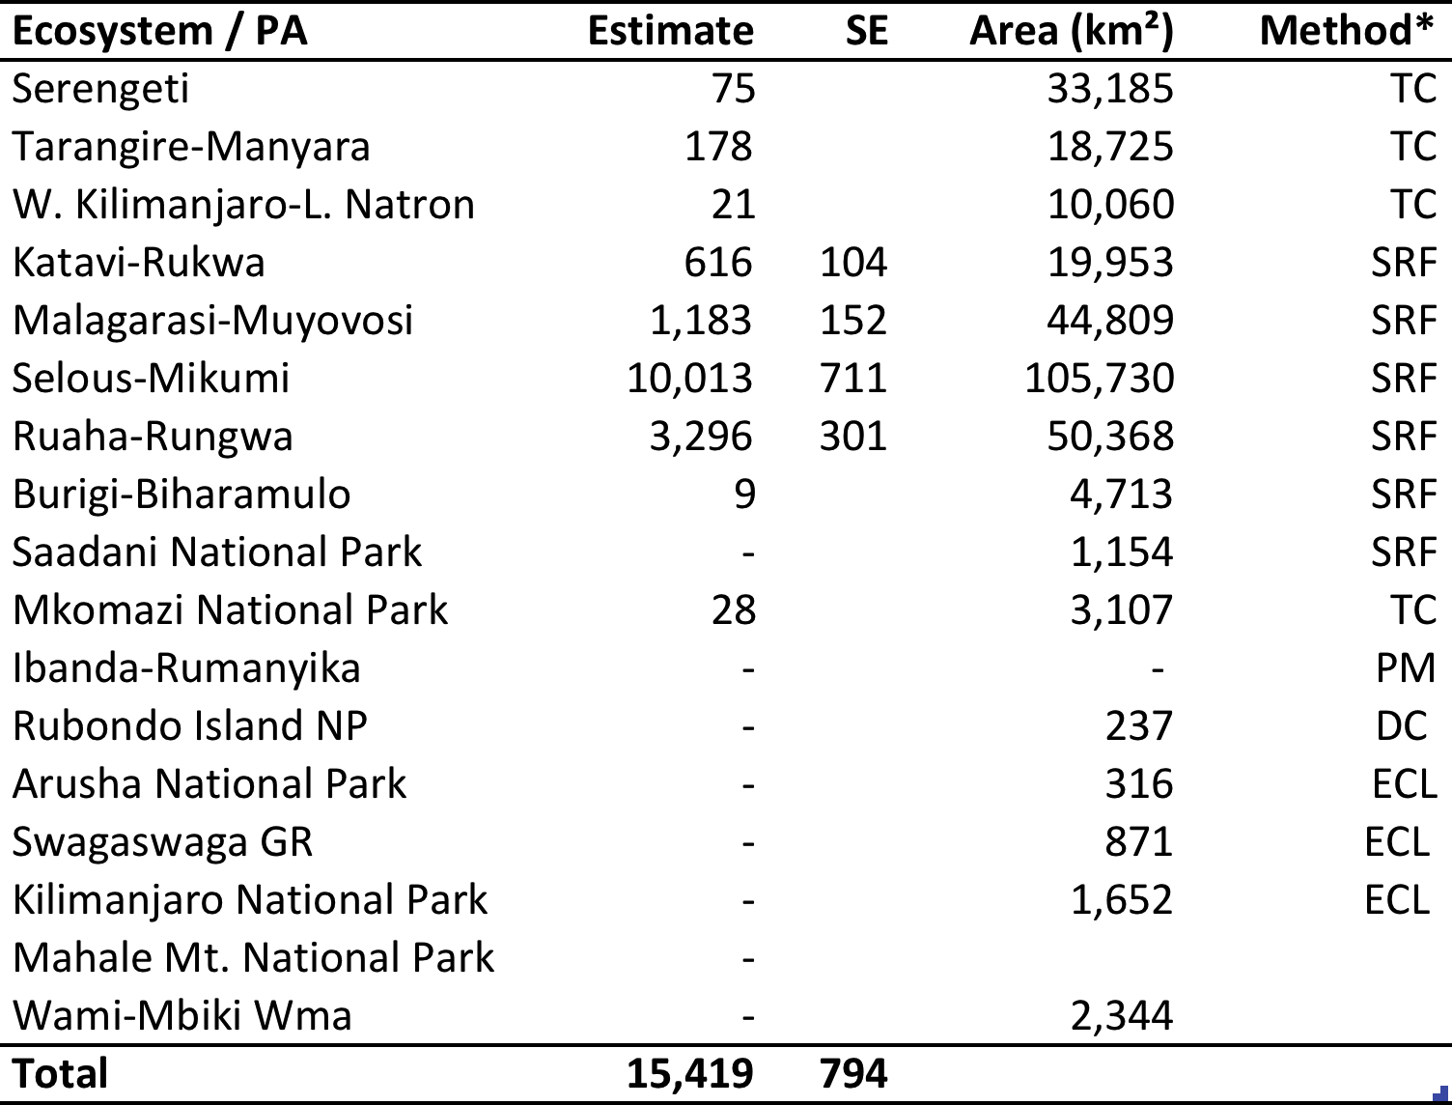
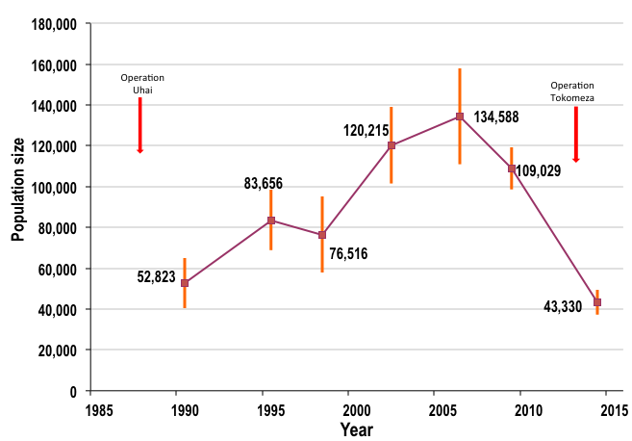
Figure 8: Tanzania elephant population trend (1990-2014). Error bars indicate 95% Confidence Interval.

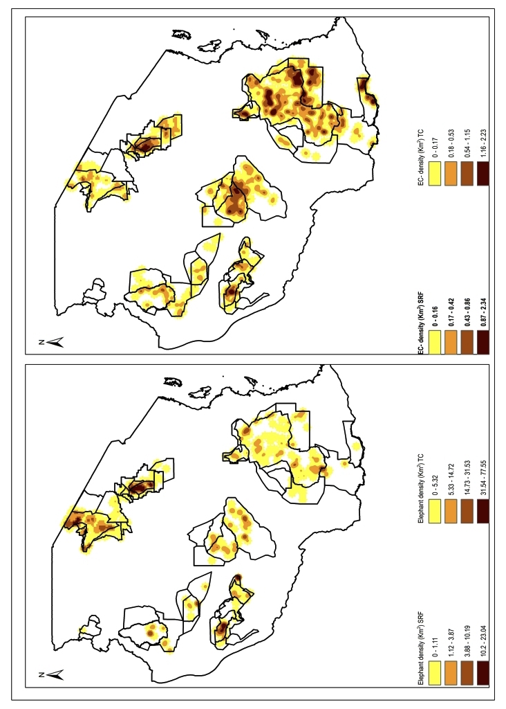
Live elephants
Carcasses

Figure 9: Distribution of elephant population density (i) and carcass density (ii) in all major ecosystems in Tanzania

5. References
Craig G.C. 2012. Monitoring the Illegal Killing of Elephants: Aerial Survey Standards for the MIKE Programme. Version 2.0. CITES MIKE programme, Nairobi
Jolly, G. M. (1969): "Sampling methods for aerial census of wildlife populations." East African Agriculture and Forestry Journal 34: 46-49.
Kenana, LM., Bakari, SK., Bitok, E. Machoke, NM., Hamzah, HK, Mukeka, J,., & Mwiu, SN, Kyale, DM, Cheptei, J (2013). Large mammal aerial total count for Amboseli – West Kilimanjaro and Magadi- Natron cross border landscape, October 2013. A technical Report for Kenya Wildlife Service (KWS), Kenya and Tanzania Wildlife Research Institute (TAWIRI), Tanzania

Mwambola S. M. 2014 Population characteristics and feeding preferences of the African elephant (Loxodonta africana) in Rubondo Island National Park, Tanzania. A Dissertation Submitted in Partial Fulfilment of the Requirements for the Degree of Master of Life Sciences and Engineering of the Nelson Mandela African Institution of Science and Technology, December 2014 Arusha, Tanzania.
TAWIRI 2009. Elephant Population Estimate in Tanzania Dry Season.

TAWIRI 2013. Population Status of African Elephant in Ruaha – Rungwa Ecosystem, Dry Season, Census Report 2013.

TAWIRI 2013. Population Status of African Elephant in Selous-Mikumi Ecosystem, Dry Season, Census Report 2013.

Norton-Griffiths, Mike. 1978. Counting Animals. Nairobi: African Wildlife Foundation.

6. Acknowledgements
We are grateful to the Government of the United Republic of Tanzania through the Ministry of Natural Resources and Tourism for permission to conduct this important nation-wide exercise and for providing material support. We are also grateful to the Director of Wildlife (WD), Director General of Tanzania National Parks (TANAPA) and Conservator of Ngorongoro Conservation Area Authority (NCAA) for their permission to conduct the survey and for providing aircrafts, personnel and logistical support. Financial support from the Paul G. Allen Foundation, the German Development Bank (KFW) and the Government of the United Republic of Tanzania is highly acknowledged. Facilitation from Frankfurt Zoological Society (FZS) by providing survey equipment and logistical support is also highly appreciated. Special thanks should go to the survey crew and to all who provided assistance in the field.
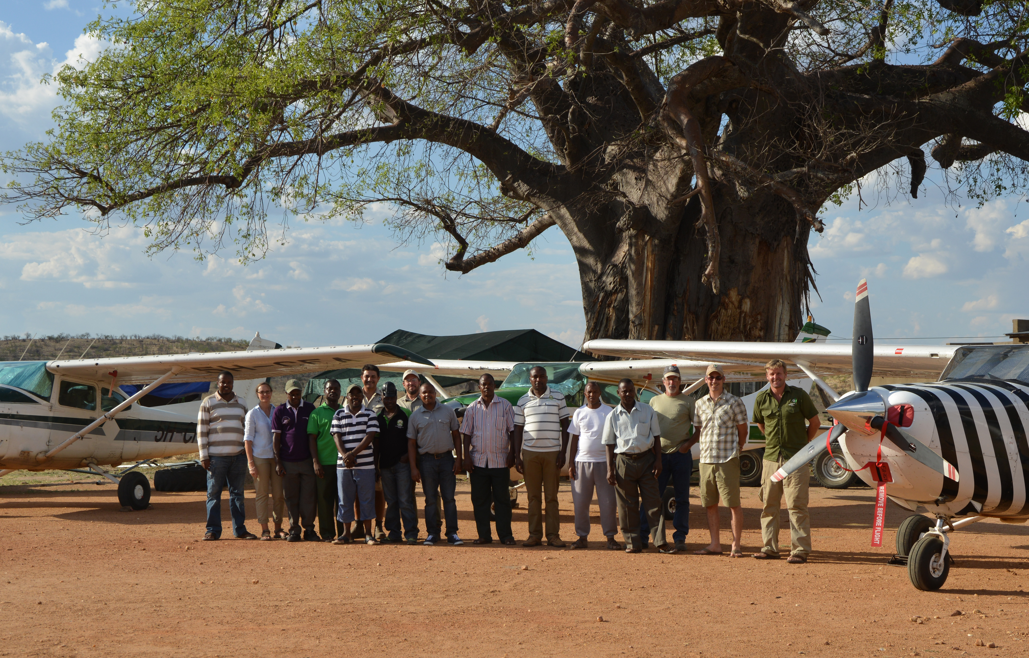
Photo: Great Elephant Census Tanzania survey team with survey aircraft in Ruaha NP. © F. Borner

